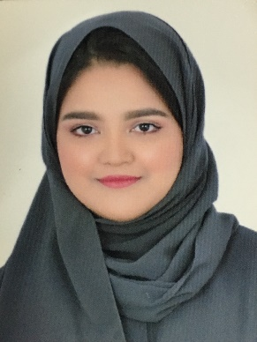

**SARA Mohammed Abdul Rahman Rashid**

**PERSONAL INFORMATION**

* Marital status: Single.
* Nationality: Bahraini.
* CPR No: 991209435
* Age: 19 years.
* Place of Birth: Riffa.
* Date of Birth:17/December/1999
* Mobile number: 33452791—39470040
* E-mail Heartsarah99@Gmail.com
* Location: madinat salman, H:3878/ R: 8141/ B: 581

**QUALIFICATION**

Commercial Secondary School certificate from Alwaffa School on 2017 (79.4)

AAT ACESS AWARD IN BUSINESS SKILLS – LEVEL1 (603\1309\2)

**Volunteer work**

I Work in the central organization for information of and statistics in Isa Town at (8AM-12PM) on (17- july-2016-21 -july -2016) as serving staff and arranging staff files at a rate of 60 hours

**LANGUAGES**

Arabic (writing/speaking/reading)

English (writing/speaking/reading)

**INTEREST & HOBBIES**

Hobbies are reading, writing, drawing.

Interest in the photography and reading books.

**skills**

Communication skills.

organization skills

Working on time.